**Lab Practice Assignment 7**

Problem 1. (30%) Equivalence partitioning

Complete “Equivalence partitioning” Example

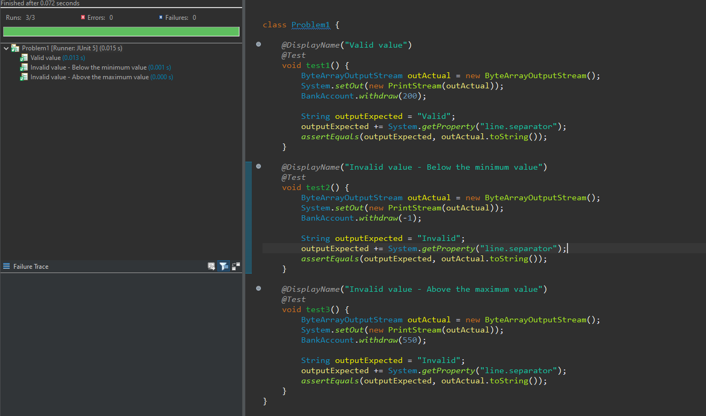

Problem 2. (30%) Boundary Value Analysis

Complete “Boundary Value Analysis” Example.

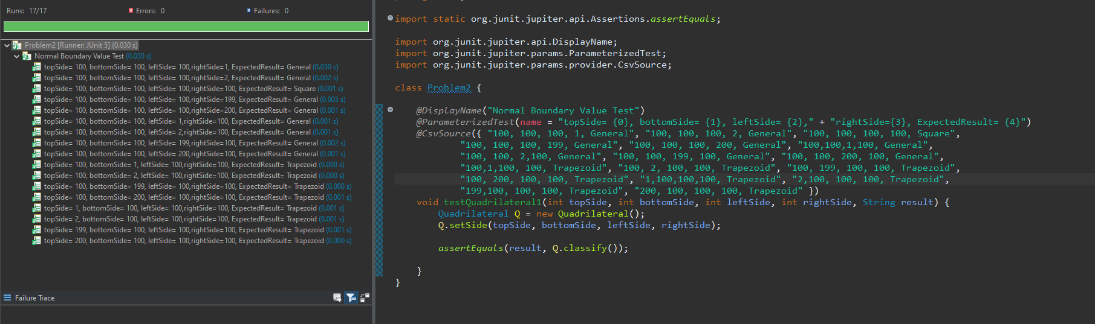

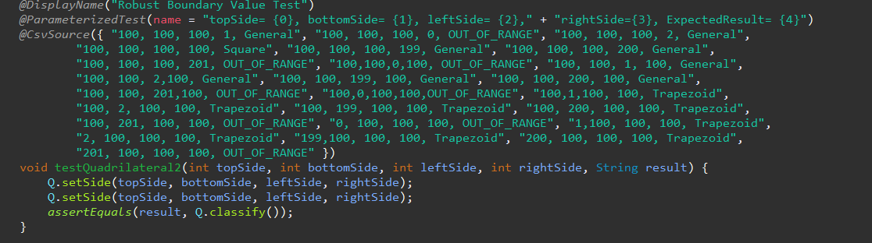

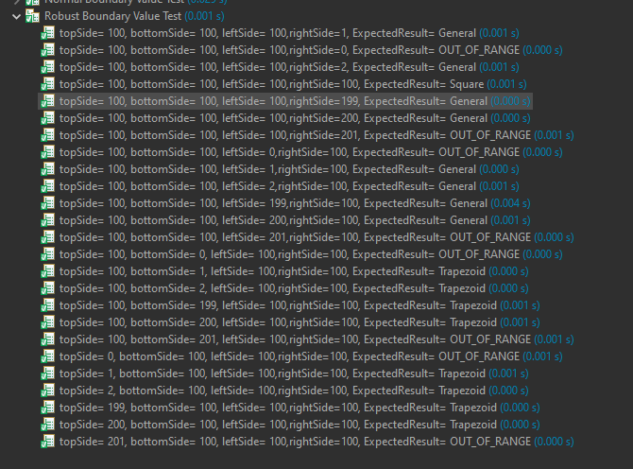

Problem 3. (40%) Decision Table

Complete “PhoneSubscription” Example and it’s corresponding “Decision Table”.

|  |  |  |  |  |  |  |  |  |
| --- | --- | --- | --- | --- | --- | --- | --- | --- |
| International | F | F | F | F | T | T | T | T |
| Auto-renewal | T | T | F | F | T | T | F | F |
| Loyal? | T | F | T | F | T | F | T | F |
| Price/month | 10 | 10 | 10 | 15 | 30 | 30 | 30 | 32 |

